15th May:
- What is the function of the cell membrane? Knew it
- What is the powerhouse of the cell? Knew it
- What is photosynthesis? Knew it
- What is DNA? Nearly
- What are enzymes? NEARLY
- What is osmosis? FORGOT IT

16th May
- What are the four bases in DNA? Knew it
- What is the function of the cell membrane? Knew it
- What is cellular respiration? Knew it
- What is the difference between prokaryotic and eukaryotic cells? Knew it
- What is the role of ribosomes? NEARLY
- What is the powerhouse of the cell? Forgot it

17th May
- What is active transport? KNEW IT
- What is photosynthesis? NEARLY
- What is DNA? FORGOT IT

18th May
- What is the powerhouse of the cell? KNOW IT
- What is photosynthesis? KNOW IT
- What is the function of the cell membrane? KNOW IT
- What is DNA? NEARLY
- What is the function of chloroplasts? KNOW IT

J What is the role of ribosomes? FORGOT it

After the three changes we asked it to make, I pressed RESET

What is the function of the cell membrane? KNOW

What is the role of ribosomes? NEARLY
What is the powerhouse of the cell?

Change as in screenshot, and then pressed reset Qs

What is the difference between prokaryotic and eukaryotic cells?

What is the function of the cell membrane?

What is osmosis?

What is the powerhouse of the cell?

What is the function of chloroplasts? NEARLY
What is the role of ribosomes? forgot

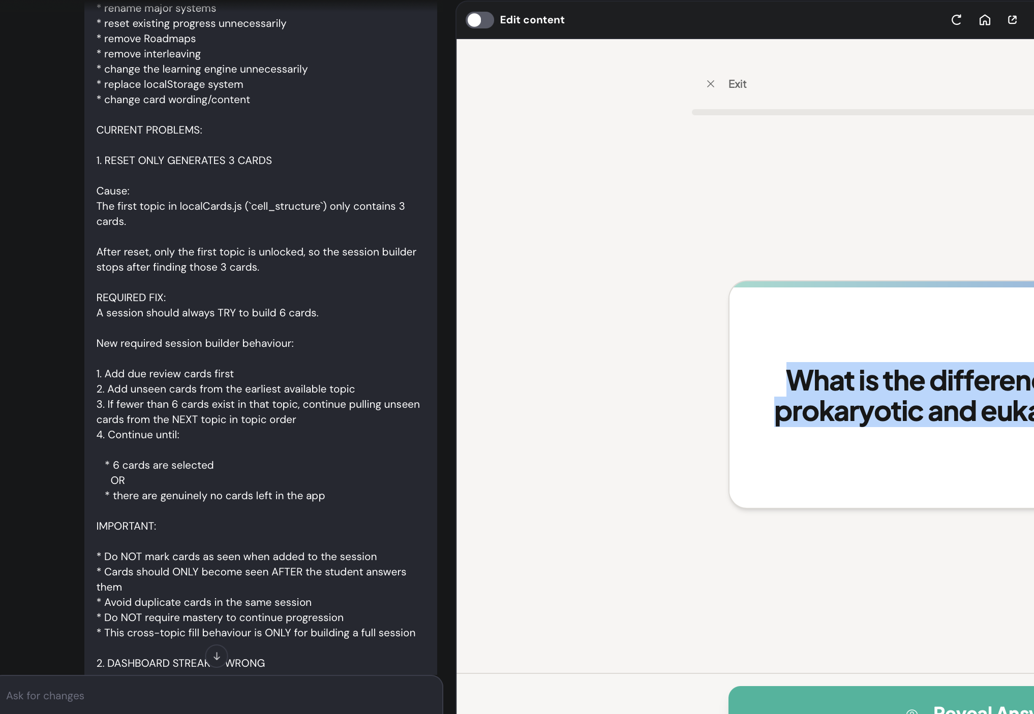

Next change, reset

How is a sperm cell adapted for its function?

What is the function of ribosomes?
What is the function of the cell membrane?

Which three structures are found in plant cells but not animal cells?

What happens in the mitochondria? Nearly

What is the function of the nucleus? I forgot
- Plus one other Q

What is the function of a sperm cell?

20th May

What controls the activities of the cell? Knew it

What contains the genetic material (DNA) in a cell? Knew it

Where do most chemical reactions happen in the cell? Knew it

What controls movement of substances into and out of the cell? Knew it

What structure supports and strengthens a plant cell? nearly

What is a specialised cell? forgot

21st May
What controls the activities of the cell?
What contains the genetic material (DNA) in a cell?
Where do most chemical reactions happen in the cell?
What controls movement of substances into and out of the cell?
What structure supports and strengthens a plant cell? NEARLY
What is a specialised cell? FORGOT


22nd May
22nd - no strike shown at the start - looks like all cards are locked again - look at road map SS. Strike came back after submitting Qs What controls the activities of the cell? KNEW IT
What contains the genetic material (DNA) in a cell? KNEW IT
Where do most chemical reactions happen in the cell? KNEW IT
What controls movement of substances into and out of the cell? KNEW IT
What structure supports and strengthens a plant cell? KNEW IT
What is a specialised cell? NEARLY

ALL THE QS:
Card_ID Topic Order Question Answer
CS01 Cell Structure1 What controls the activities of the cell? Nucleus
CS02 Cell Structure2 What contains the genetic material (DNA) in a cell? Nucleus
CS03 Cell Structure 3 Where do most chemical reactions happen in the cell? Cytoplasm
CS04 Cell Structure 4 What controls movement of substances into and out of the cell? Cell membrane
CS05 Cell Structure 5 What structure supports and strengthens a plant cell? Cell wall
SC01 Specialised Cells1 What is a specialised cell? A cell adapted to carry out a particular function
SC02 Specialised Cells2 What is the function of a sperm cell? To fertilise the egg cell
SC03 Specialised Cells3 Name one adaptation of a sperm cell long tail to swim to the egg
SC04 Specialised Cells4 Name another adaptation of a sperm cell Many mitochondria for energy
SC05 Specialised Cells5 Name a third adaptation of a sperm cell Acrosome containing enzymes to penetrate the egg
TR01 Transport in Cells1 What is diffusion? The movement of particles from an area of high concentration to an area of low concentration
TR02 Transport in Cells2 Where does diffusion happen in cells? Across the cell membrane
TR03 Transport in Cells3 What is osmosis? The movement of water from a dilute solution to a more concentrated solution through a partially permeable membrane
TR04 Transport in Cells4 What type of membrane is involved in osmosis? A partially permeable membrane
TR05 Transport in Cells5 What is active transport? The movement of substances from low concentration to high concentration using energy
TR06 Transport in Cells6 Why does active transport require energy? Because substances are moved against the concentration gradient
TR07 Transport in Cells7 Give one example of active transport in plants Mineral ions absorbed by root hair cells from the soil
CD01 Cell Division1 What is cell division? The process by which a cell splits to form new cells
CD02 Cell Division2 Why do cells divide? For growth, repair and replacement
CD03 Cell Division3 Are new cells produced by cell division identical or different? Identical
CD04 Cell Division4 Why must new cells be identical? So tissues continue to function properly
CD05 Cell Division5 Where does cell division happen in the body? Throughout the body
CD06 Cell Division6 What happens to old or damaged cells? They are replaced by new cells
ST01 Stem Cells1 What is a stem cell? An unspecialised cell that can divide and differentiate into specialised cells
ST02 Stem Cells2 What does differentiation mean? The process by which a cell changes to become specialised
ST03 Stem Cells3 Where are stem cells found in embryos? Embryos
ST04 Stem Cells4 Where are stem cells found in adults? Bone marrow
ST05 Stem Cells5 What can stem cells be used for in medicine? To replace damaged cells and treat some diseases

